Weekly report

1. **My *Goals* from last week**
   1. Find a working edge for the covariance experiment
   2. Do the torque experiment
2. **My *Accomplishments* this week**
   1. Project 1: <Covariance Experiment>
      1. Tested 3 more new edge ideas
      2. Added feet to the new idea such that it is the same height as the kilobots
      3. Created enough edges of the final edge decision to create a full border not making an angle past 45 degrees
         1. *<Deliverable 1&2>Pictures of part below with kilobit for size reference. Part can be found in lasercutter folder under robotinlets.dwg*

*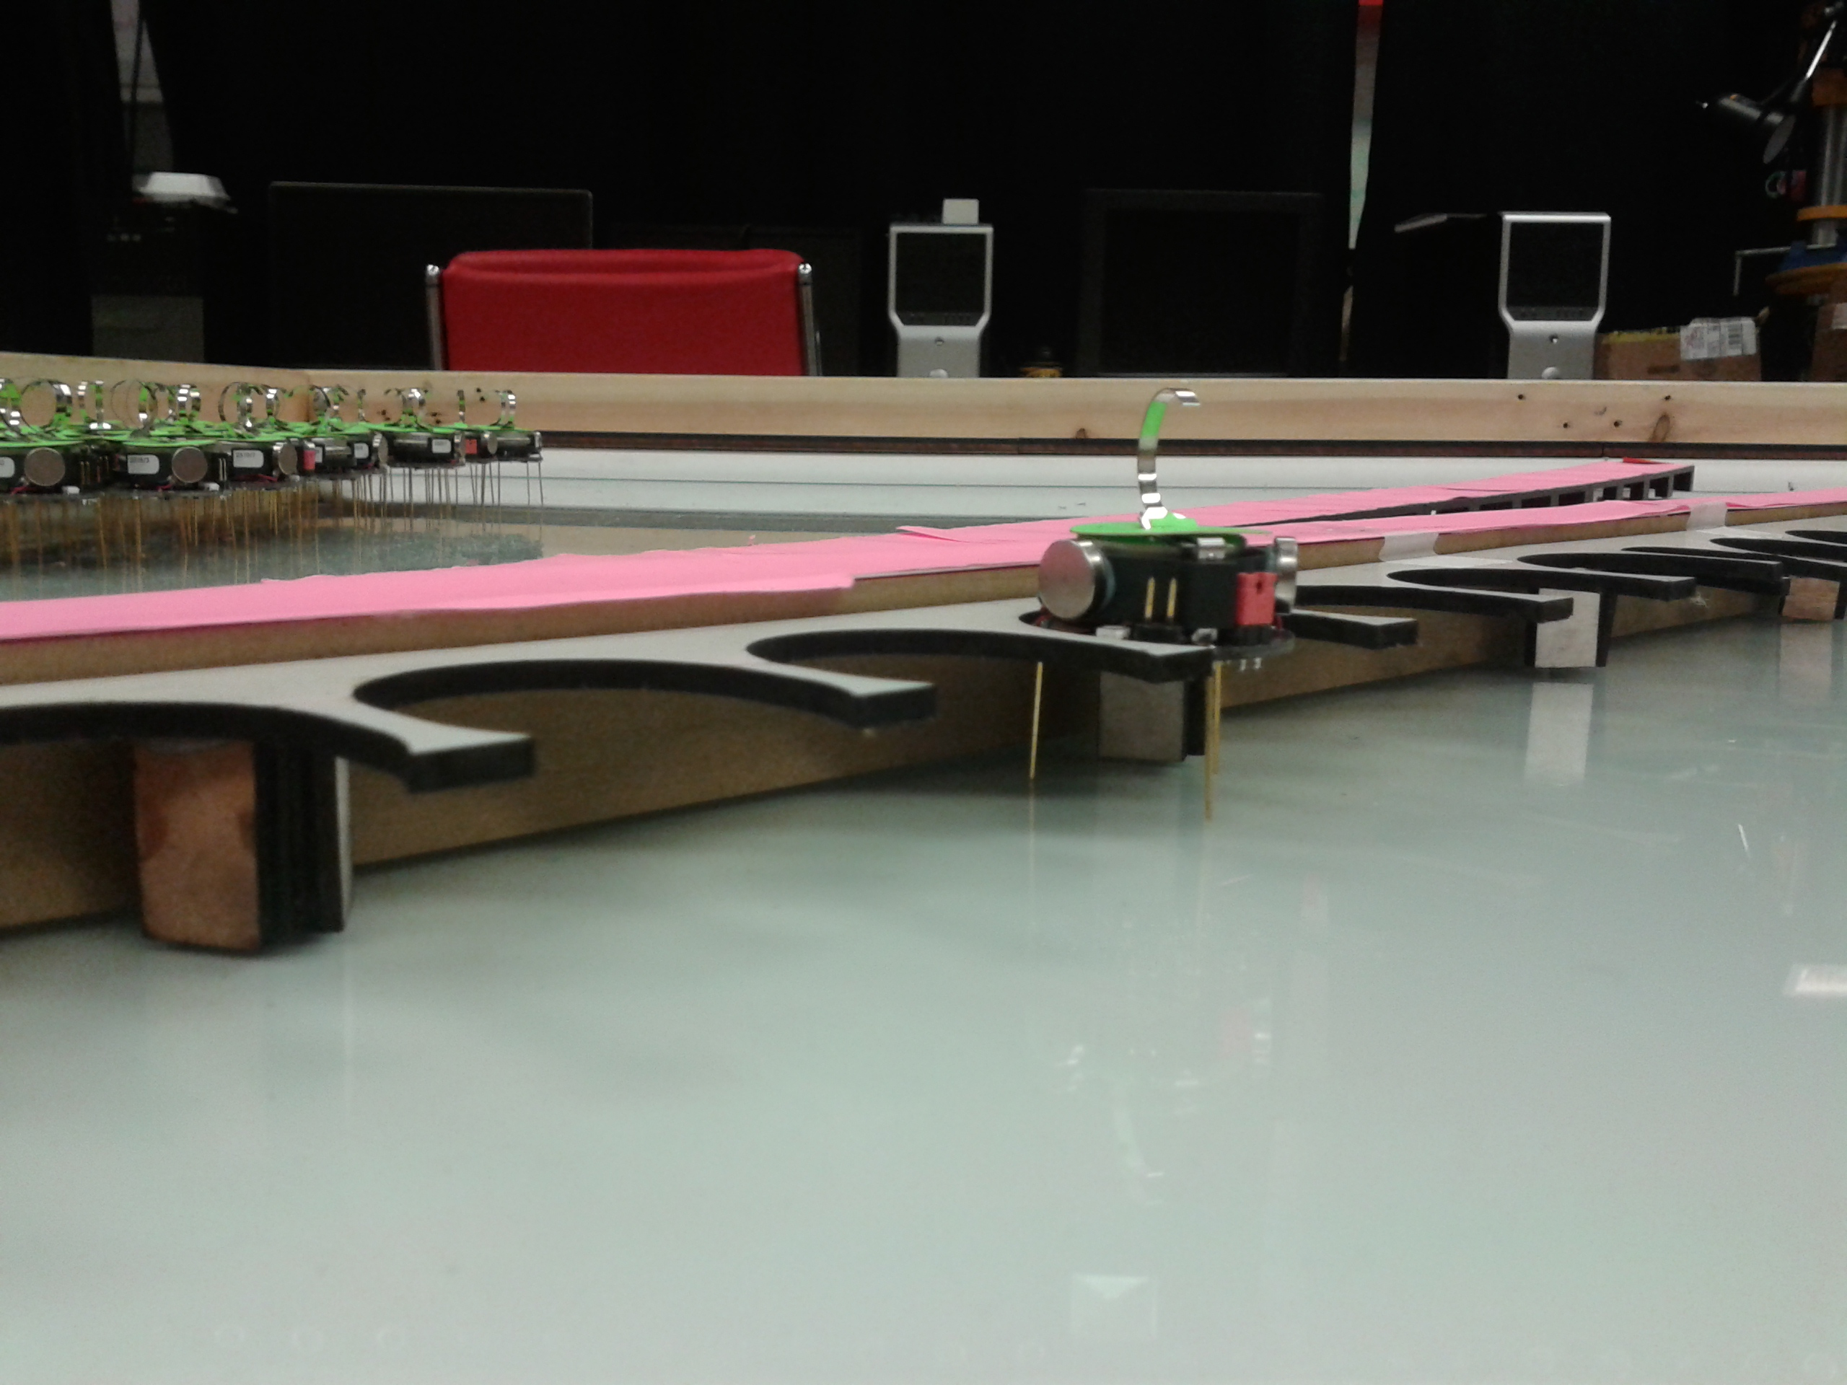*

Figure - Covariance Edge

* + 1. Did multiple runs of covariance experiment
  1. Project 2: <Torque Experiment>
     1. Found that the robots pushed the object so far it was running into the corner of the object and not making an angle past 45 degrees
        1. Created a new loop part to compensate for this
        2. *<Deliverables 3&4> Picture of part below. Code is on github under loop part.ipt*

*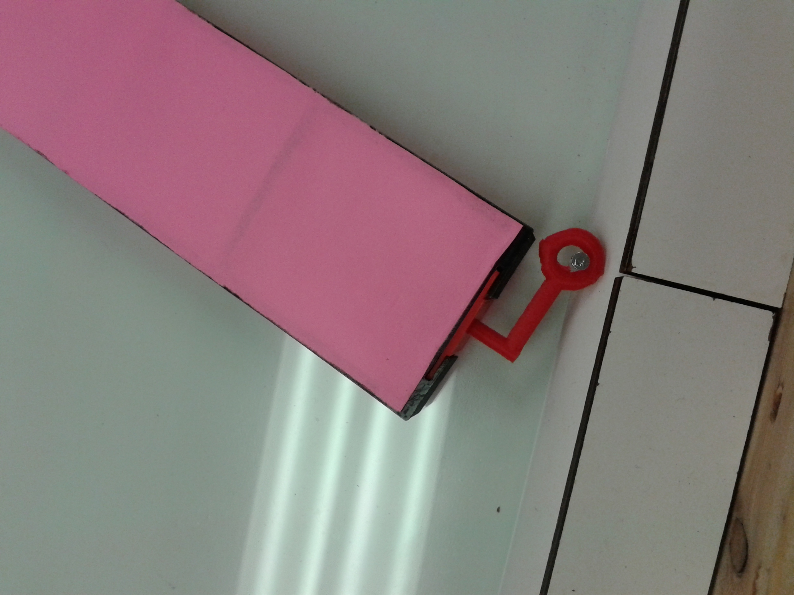*

Figure - New Loop Design

* 1. Project 3: <Orientation Control Experiment> Experiment>
     1. Asks the user initially what goal angle they would like (as currently I do not know how Shiva wishes to randomize the goal angle,defaults at 30 if no angle is input)
     2. Tested current code without running robots (works 75 percent of the time)
        1. The code doesn’t recognize the outside angle depending on which side of 90 the object is oriented at (See picture example below)

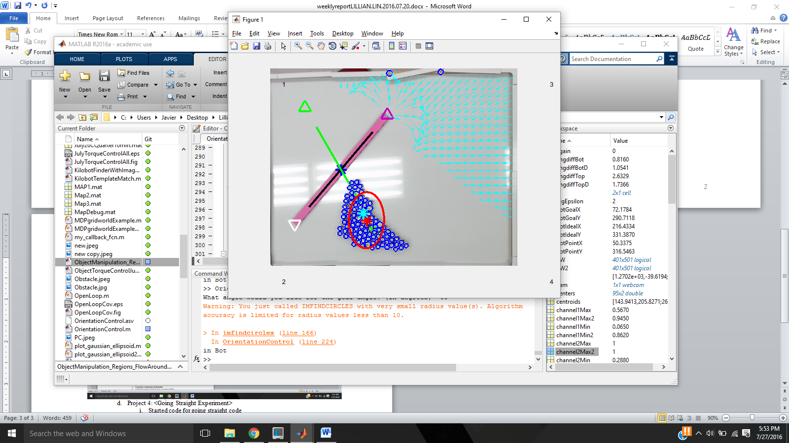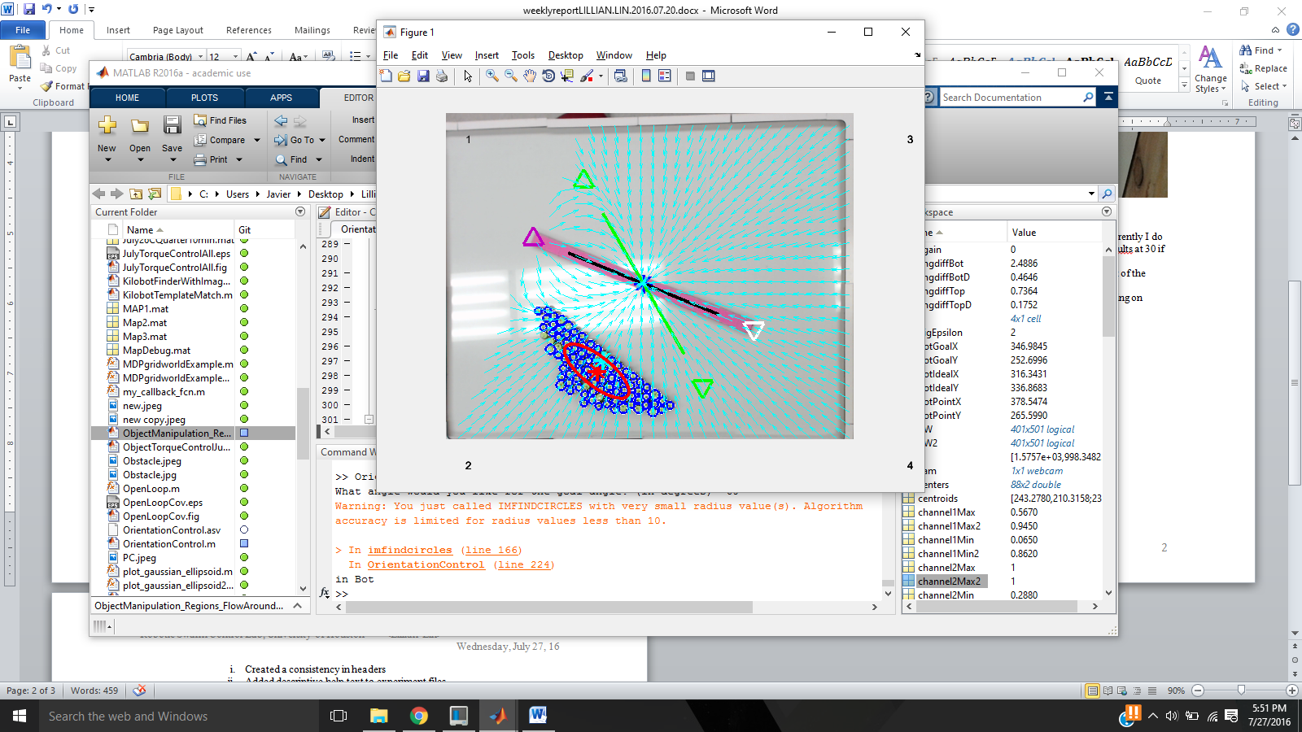

Figure - Same code and same goal angle but different object orientation. Showing top flow around position. Error on left and correct on top

* 1. Project 4: <Going Straight Experiment>
     1. Started code for going straight code
     2. *<Deliverables 5> Code is on github under GoingStraight.m*
  2. Project 5: <Github Clean-up>
     1. Created a consistency in headers
     2. Added descriptive help text to experiment files
     3. Linked in help text to used functions
  3. Project 6: <IJRR Paper>
     1. Made edits with Dr Becker, Shiva, and Mable
  4. Project 7: <Other>
     1. Created a checklist/schedule of when Mahek should finish aspects of her game by
     2. Went to Houston Robotics and AI day at UHCL
        1. Created a powerpoint to present
        2. Gave a 5 minute speech about the swarmcontrol.net games
        3. Presented a poster
        4. Networked with people from UHCL & Rice
     3. Created tape markings on the ground to know where the table goes

1. **My *Goals* for next week**
   1. Make new pictures for IJRR paper with green robots, cyan arrows, a black object, and no grey circle
   2. Make the Orientation Control Experiment work for the remaining 25 percent of the time
      1. Make the correct portion flow around despite what angle the code is at
      2. Make the robots go into variance control when object is at the correct angle
   3. Get good data for covariance experiment
   4. Learn how to spell “experiment” as I keep spelling it wrong in these weekly reports for some reason…